**Immersive Visual Pattern Test**

(left) **Traditional Visual Pattern Test**: examines **short-term visual memory**.

(right) **Immersive Visual Pattern Test**: examines **visuo-spatial memory** and kinaesthetic memory.

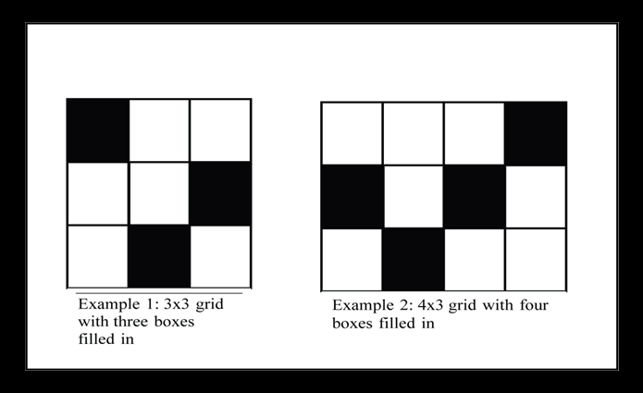 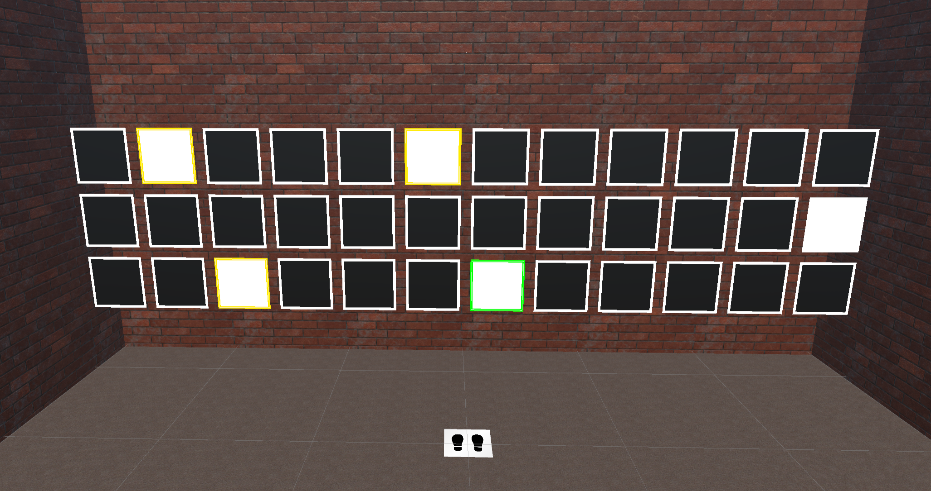

**Study Factors and Conditions**

**Factors:**

* **Physical environment** (furniture vs no furniture)
* **Card Layout** (regular vs irregular)

**Conditions:**

Furniture + Irregular Layout Furniture + Regular Layout

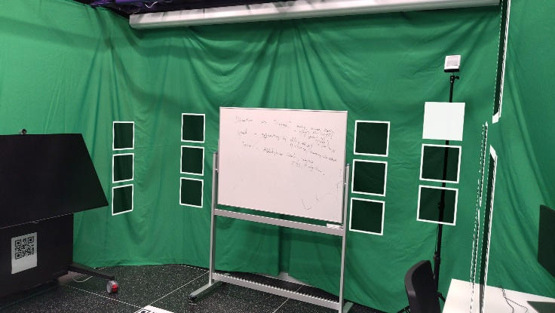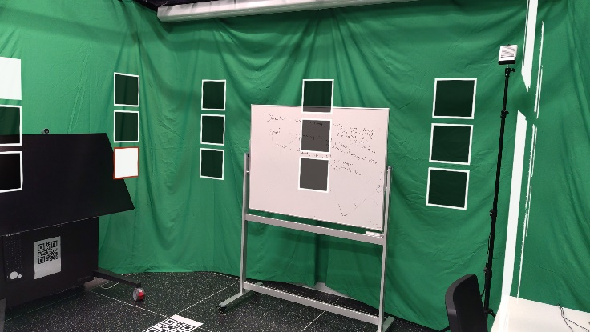

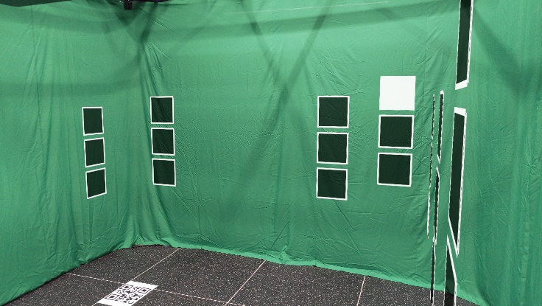 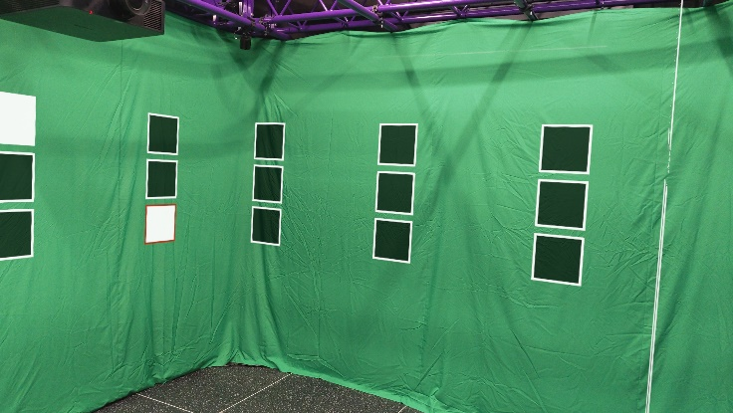

No Furniture + Irregular Layout No Furniture + Regular Layout

This experiment has 24 trials (1 training + 5 experimental trials per condition).

Each experiment trial has five phases: **preparation**, **learning**, **distractor**, **recall,** and **rest**.

1. **Preparation** **phase**:
   1. Stand at the starting position and press a button to go to the learning phase when ready.
2. **Learning** **phase**:
   1. There are **5 white cards out of 36 cards** (2 out of 4 in the training scene). You need to remember the position for all the white cards. (image b)
   2. When you see any white card, its border colour turns orange. Then you need to touch it. The border colour must turn green after seeing and touching it.
   3. You have **15 seconds** to perform the memorisation.
   4. After seeing and touching all the white cards, you will be navigated to the distractor phase.
3. 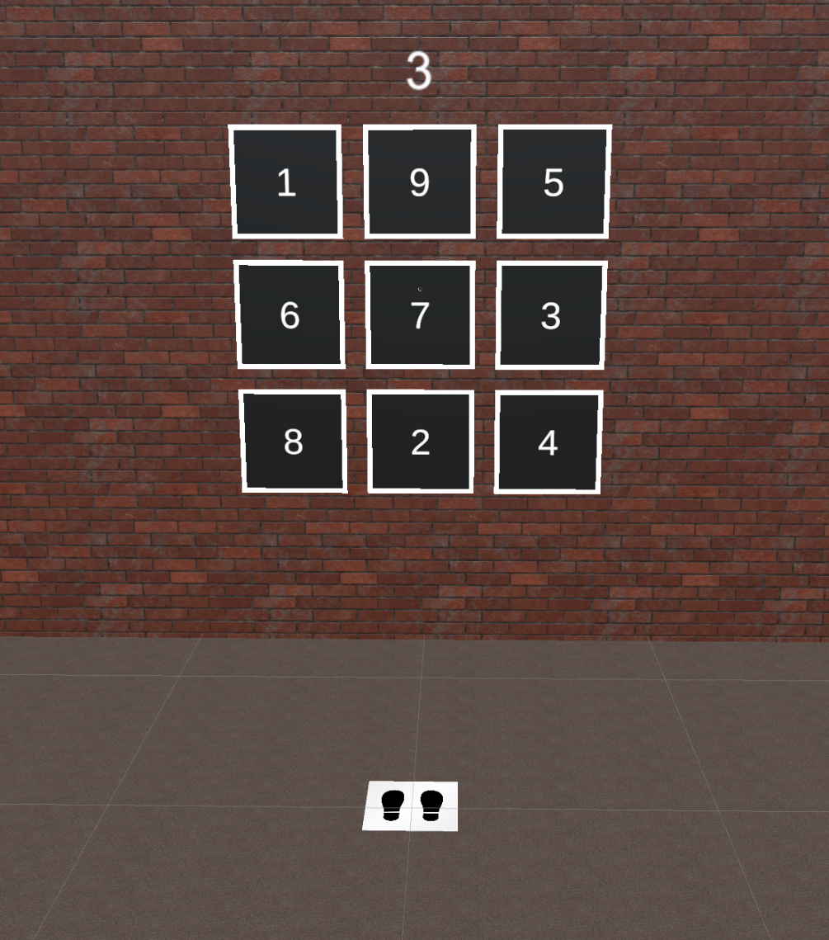**Distractor phase:**
   1. You will play a number-touching game in 15 seconds by default. You need to use your hand to touch the number card as instructed.
   2. You can see the task and the current timer on the hand menu.
   3. If you touch the wrong card or have no interaction for more than 5 seconds, the timer will be added 5 more seconds, capped at 15 seconds.
   4. When the timer reaches 0, you will be navigated to the recall phase.
4. **Recall phase:**
   1. You need to select (touch the card) 5 cards as you remembered.
   2. There is no time limit for this phase.
   3. You CANNOT undo what you’ve selected.
   4. Press a button to confirm your answer.
5. **Rest phase:**
   1. Press a button to go to the preparation phase for the next trial.

Note: when you feel the virtual cards are not in regular positions (drifting), please check whether the virtual footprint icon is aligned with the physical one on the floor.

If they are not aligned properly, a re-calibration is needed.